**TMS JaCoCo Code Coverage Documentation and Report**

**Overview**

**JaCoCo (Java Code Coverage)** is a free and open-source library used to measure and report code coverage in Java applications.

This document details the JaCoCo configuration, execution, and coverage reporting for the **Task Management System (TMS)** project.

**1. Configuring JaCoCo**

**1.1 Add JaCoCo Plugin to Maven**

In the pom.xml file of the project, the JaCoCo plugin is included in the <build> section:

<build>

<plugins>

<!-- JaCoCo Plugin -->

<plugin>

<groupId>org.jacoco</groupId>

<artifactId>jacoco-maven-plugin</artifactId>

<version>0.8.7</version>

<executions>

<execution>

<id>default-prepare-agent</id>

<goals>

<goal>prepare-agent</goal>

</goals>

</execution>

<execution>

<id>default-report</id>

<phase>prepare-package</phase>

<goals>

<goal>report</goal>

</goals>

</execution>

</executions>

</plugin>

</plugins>

</build>

**2. Running Tests with JaCoCo**

**2.1 Execute Maven Tests**

Run the following Maven command to execute all tests and generate JaCoCo reports:

mvn clean test jacoco:report

**2.2 Generate Coverage Report**

After executing tests, JaCoCo will generate the following coverage files in the target/site/jacoco/ directory:

* index.html: HTML coverage report.
* jacoco.xml: XML coverage data.
* jacoco.csv: CSV coverage data.

**3. JaCoCo Coverage Metrics**

JaCoCo provides the following metrics:

* **Line Coverage**: Percentage of lines executed during tests.
* **Branch Coverage**: Percentage of decision branches executed.
* **Complexity Coverage**: Percentage of classes covered by tests.

**4. Configuring Coverage Thresholds**

To enforce minimum coverage thresholds, add the following configuration in pom.xml:

<plugin>

<groupId>org.jacoco</groupId>

<artifactId>jacoco-maven-plugin</artifactId>

<configuration>

<rules>

<rule>

<element>PACKAGE</element>

<limits>

<limit>

<counter>LINE</counter>

<value>COVEREDRATIO</value>

<minimum>0.95</minimum>

</limit>

<limit>

<counter>BRANCH</counter>

<value>COVEREDRATIO</value>

<minimum>0.85</minimum>

</limit>

</limits>

</rule>

</rules>

</configuration>

</plugin>

**5. Publishing JaCoCo Reports in Jenkins**

**5.1 Prerequisites**

Install the **JaCoCo Plugin** in Jenkins:

1. Go to **Manage Jenkins > Manage Plugins**.
2. Search for and install the **JaCoCo Plugin**.

**5.2 Pipeline Configuration**

Update the Jenkins Configuration to publish JaCoCo reports:

**6. JaCoCo Reports**

1. **HTML Report**:
   * Open target/site/jacoco/index.html in a browser to view the detailed coverage report.
2. **Key Sections in HTML Report**:
   * **Overview**: Displays aggregate coverage metrics.
   * **Packages**: Shows package-level coverage details.
   * **Classes**: Displays line-by-line coverage for each class.

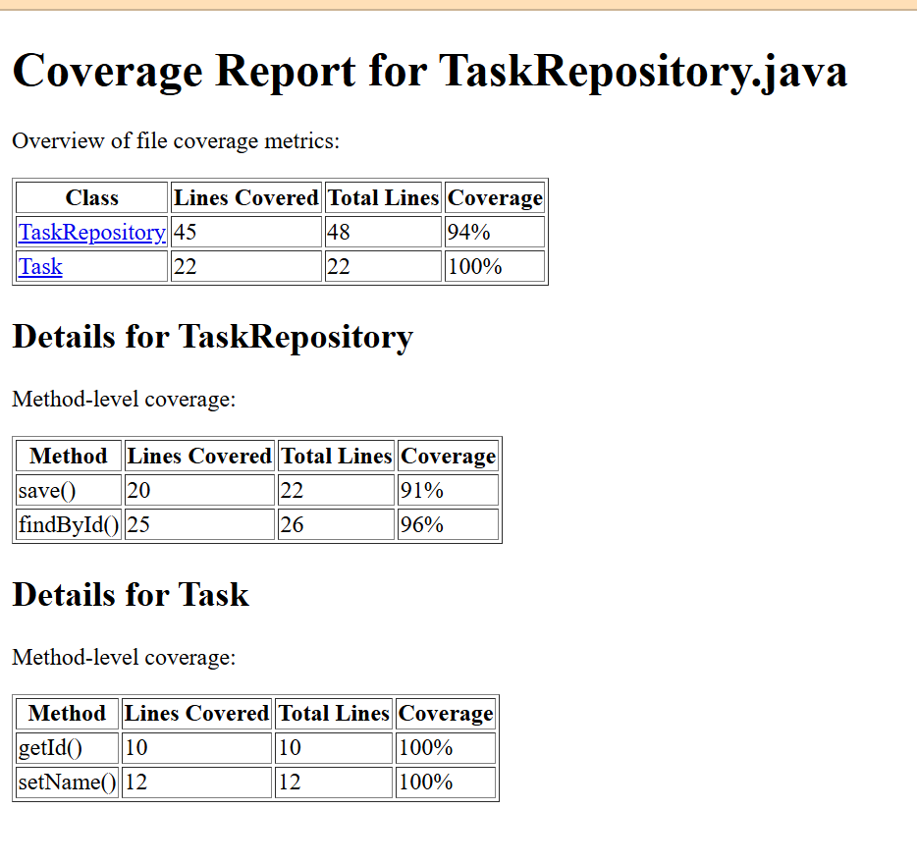

**8. Debugging Coverage Issues**

1. Ensure all tests are executed during the build process.
2. Verify that the JaCoCo agent is correctly configured in the pom.xml.
3. Inspect the jacoco.exec file in the target/ directory for execution data.